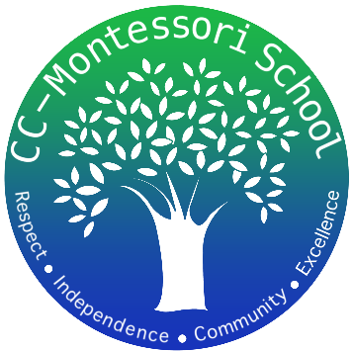
Corpus Christi Montessori School
A Free Public Charter

822 Ayers Street
Corpus Christi, Texas
(361) 852-0707
www.cc-montessori.com
Physical Education Guide
School
Corpus Christi Montessori School (a Public Charter School)
822 Ayers St., Corpus Christi, Texas 78404; 361-852-0707
Contact: Ada Flores Email: ada@cc-montessori.org or cerise@cc-montessori.org

Title
Physical Education Guide/Coach – Multi-aged group setting working with grades 1st-8th. Lower elementary classes consist of 1st-3rd grade, upper elementary consists of 4th-6th, and middle school is 7th and 8th. Classes range from 25 - 40 students with an assistant teacher to support.

Salary
Negotiable depending on years’ experience and certification. Go to www.cc-montessori.com for a salary schedule.

Duty Days: 187 (includes professional development days)

Start Date: August 2, 2023

Subject Area/Teaching Field Endorsement/Requirements
Texas Certified
Bachelor's degree from accredited university
Valid Texas teaching certificate with required endorsements or required training for subject and level assigned or experience working with children
Montessori experience or understanding of Montessori philosophy a bonus

Description: School Year 2023-2024
The occupation of Physical Education Guide/Coach is one that has a strong impact on the students of our campus. The coach often forms strong bonds with the students and is incredibly important to the campus culture. The Physical Education Guide/Coach is responsible for:
-Co-teaching with an assistant.
-Coaching Girls Volleyball, Girls Basketball, Boys Basketball and Girls/Boys Track during their respective seasons.
-Working with local groups (Parochial leagues, CCISD) to set up game opportunities.
-Working outside with students while maintaining safety and proximity or inside during unsafe weather conditions.
-Helping to mentor students who may need extra adult guidance.
-Bringing different methods of exercise, health, and mindfulness practices to the children.
-Be flexible and available to work in a classroom setting or monitor students at director’s discretion excluding planning periods.
Application available online: www.cc-montessori.com
Close Date: Open until filled
Qualifications:
- Demonstrate a positive work attitude and can establish and maintain excellent relationships with staff, parents, and students.
- Flexibility
- Have great classroom management
- Demonstrate the tracking of student progress
- Dedication to demonstrate philosophy and methodology of “children come first” and appropriately applied to the age-level taught.
- Successful utilization of key Montessori concepts into practice. One of which is – meet the child where they are and move forward.
- Work closely and collaboratively with campus teachers and staff.
- Ability to work well with a diverse group of students and parents, and to work within the school community to create a strong professional learning environment.
- Strong work ethic with excellent communication and presentation skills.
Creative, inspirational, self-directed, positive, and committed with a “can-do attitude”
- Willing to learn from and work well with fellow faculty members.
- Understand the importance of TEKS and state standards and implementing the within the curriculum.
Benefits:
- Competitive Salary
- Paid Personal, Sick and Teacher Workdays
- TRS Retirement Plan
- Health Insurance Opportunities
- Professional Development Opportunities
- Positive and Friendly Staff
- Supportive Parents
- Respectful Students
- Safe Working, Pleasant and Flexible Environment
- Montessori Training Opportunities

