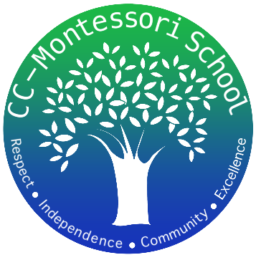
Corpus Christi Montessori School
A Free Public Charter

822 Ayers Street
Corpus Christi, Texas
(361) 852-0707
www.cc-montessori.com
Music Teacher
Charter School
Corpus Christi Montessori School (a Public Charter School)
822 Ayers St., Corpus Christi, Texas 78404; 361-852-0707
Contact: Ada Flores Email: ada@cc-montessori.org

Title
Independent Contractor Music Teacher – Multi-age grouping (Grades 1st-8th)

Part Time
12-16 hours per week. 12:45 pm-3:45 pm Monday-Thursday. 10:00 pm-12:00 pm Friday.

Salary
$20.00 - $25.00 depending on years of experience and credentials

Start Date
August 2023

Subject Area/Teaching Field Endorsement
Background in multiple instruments, choral singing, and working with children a plus.
Description
School Year 2023-2024
The music teacher will teach all grades the basics of music theory and sight reading for vocal and instrumental music. Explore many types of music with the children. They will work with classroom teachers when possible to support classroom learning and plan one or more performances throughout the year.
Requirements (Additional Information)
High school diploma, min. 60 college hrs. preferred. Bilingual preferred but not required.

Application available online:
www.cc-montessori.com Application for Independent Contractor.

Close Date
Open until filled

Qualifications:
- Excellent organizational skills.
- Demonstrate a positive work attitude and can establish and maintain excellent relationships with staff, parents and students.
- Classroom management experience.
- Dedication to the Montessori philosophy of whole child development and fostering respect for self, respect for others, and respect for the environment.
- Work closely and collaboratively with other team members.
- Ability to work well with a diverse group of students and parents, and to work as a professional within the school community to create a strong professional learning environment.
- Strong work ethic with excellent communication and presentation skills.
Creative, inspirational, self-directed, positive, and committed with a “can-do attitude”.
- Willing to learn from and work well with fellow faculty members.

Benefits:
- Positive and Friendly Staff
- Supportive Parents
- Small Community
- Respectful Students
- Safe Working and Pleasant Environment

